KPI 1: Site Utilization

Site utilization is crucial for optimizing e.g. the resource allocation of EV charging stations. Both sites exhibit a parabolic pattern with peak utilization, site 1 at ~10AM and site 2 at ~12PM. There is significant decline during the Coronavirus pandemic in 2020. This understanding is vital for resource allocation, growth planning, and station performance monitoring.

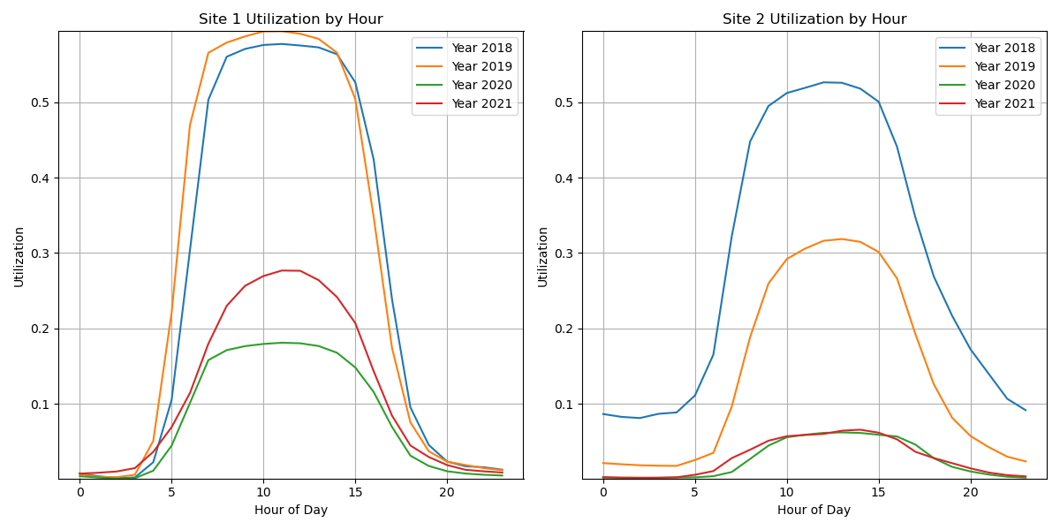

KPI 2: Average Session Duration

Average Session Duration reveals session length and station turnover. Sessions often exceed charging times, suggesting cars remain parked longer than needed, especially overnight.

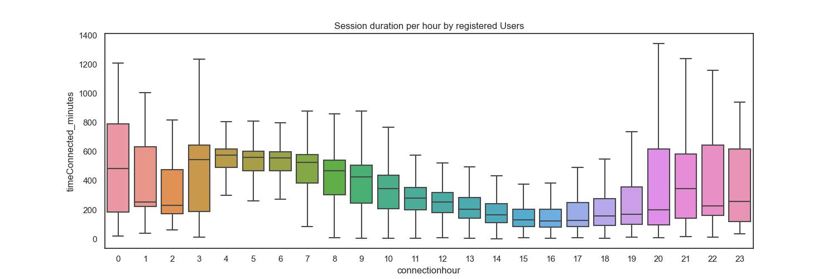

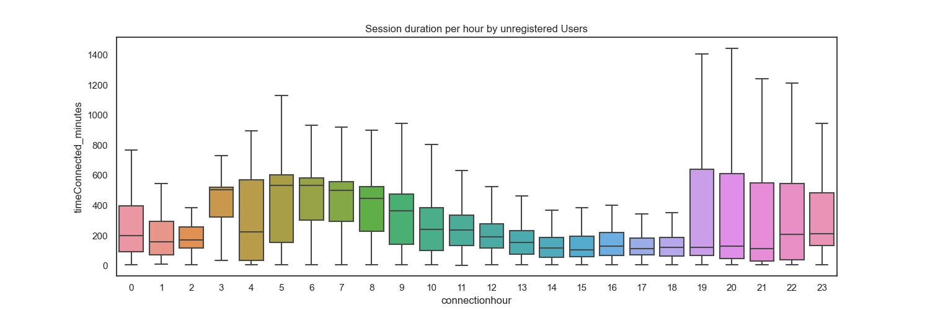

KPI 3: Idle Time

Idle Time measures station efficiency. Idle times mirror session lengths, suggesting potential for improved turnover rates. Variability is observed in idle times.

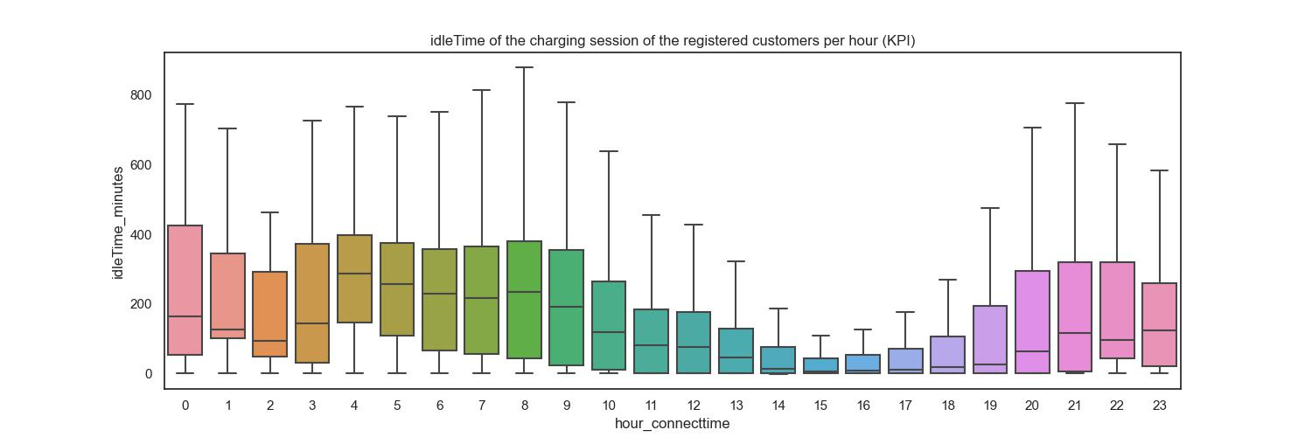

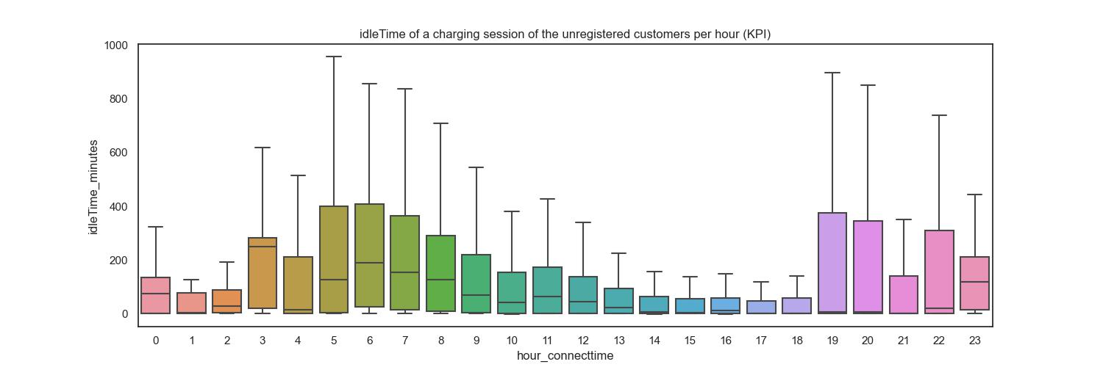

KPI 4: General Demand

General Demand tracks hourly station usage trends. Similar patterns are seen for registered and unregistered users, with peak usage at 6-7 AM. Unregistered users show a 5 PM spike, diverging from registered users' nighttime decline.

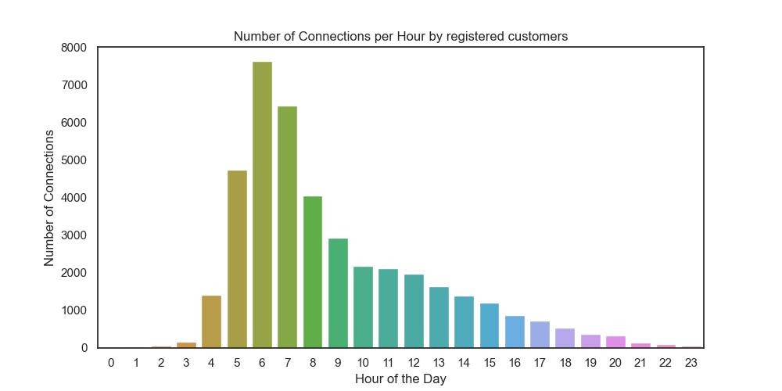

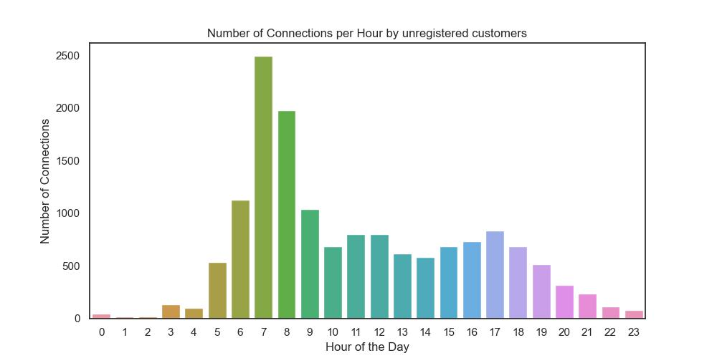

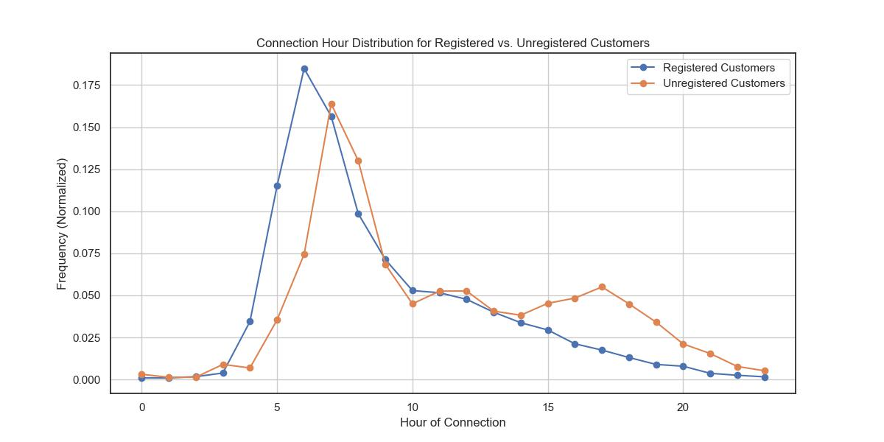

Appendix:

KPI 5 Charging duration:

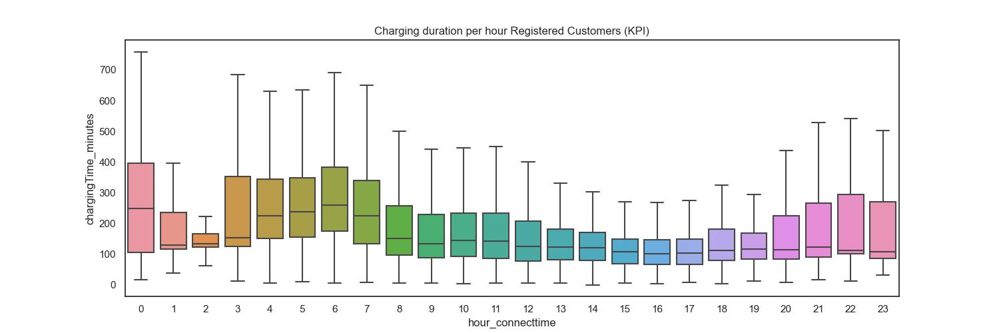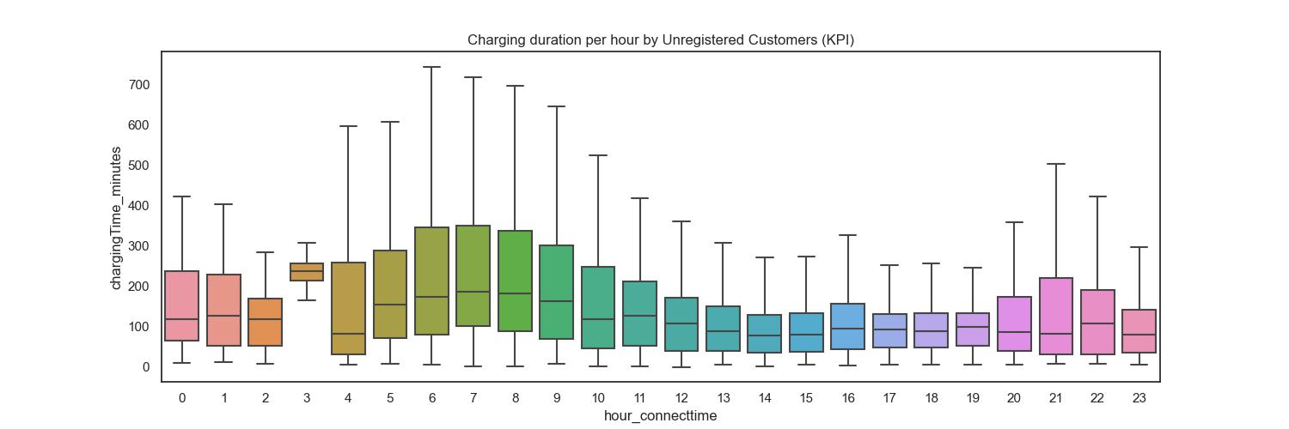

KPI 6 Propotion of the stations:

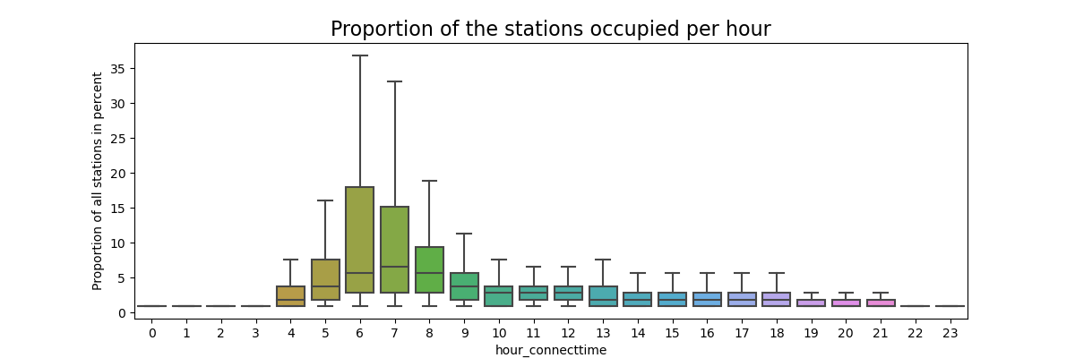

KPI 7 Average kdW delivery:

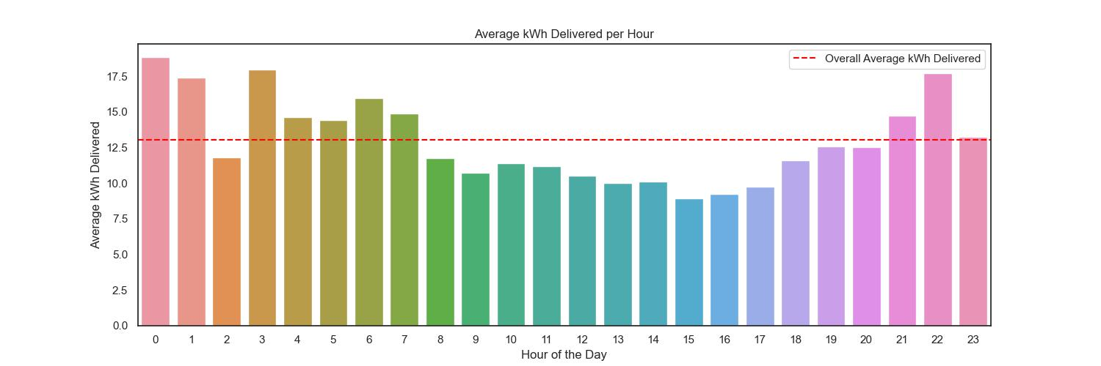

KPI 8 Top 10 utilized stations:

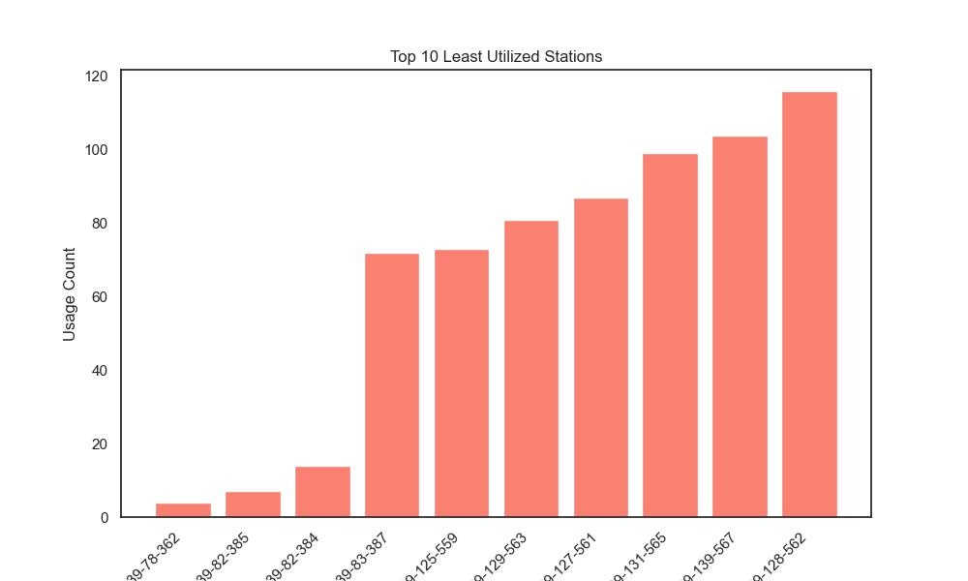

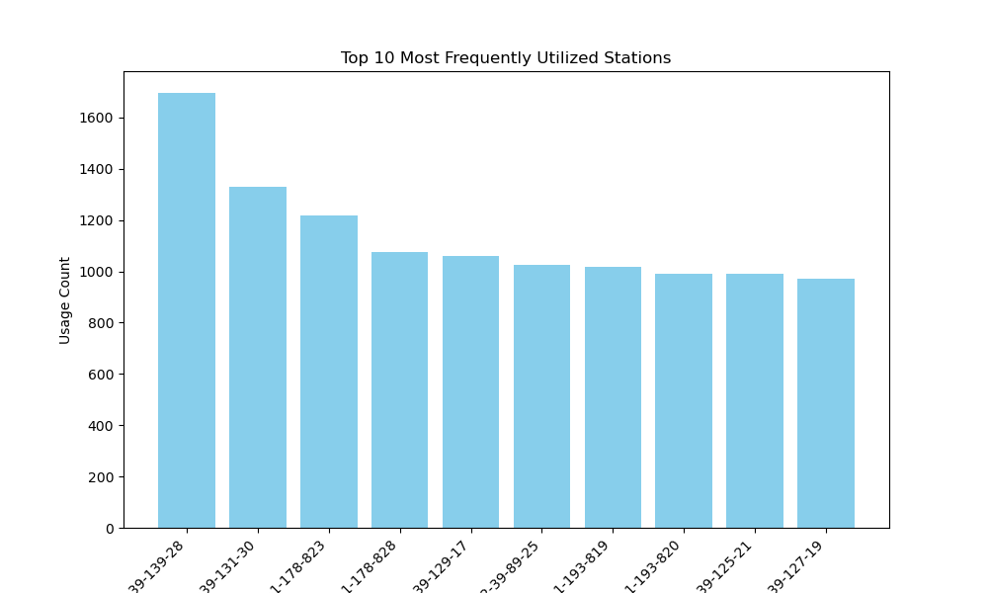

KPI 9 General Ratio between Registered and unregistered customers:

